Experiment Number : 03 Date: 29.01.2026

Control Statements in Java
Aim:
To understand and implement decision-making and looping control statements in Java.
PRE LAB EXERCISE
QUESTIONS
Q1. List different control statements in Java.
Ans:
• Selection statements: if, if-else, switch
• Iteration statements: for, while, do-while
• Jump statements: break, continue, return
Q2. Difference between for, while, and do-while loops.
Ans:
• for loop: Used when number of iterations is known.
• while loop: Condition is checked before loop execution.
• do-while loop: Executes at least once; condition checked after execution.
Q3. What is the use of break and continue?
Ans:
• break: Terminates the loop or switch immediately.
• continue: Skips current iteration and moves to next one.
IN LAB EXERCISE
Objective:
To implement if-else and looping statements.
INPUT STATEMENT:
SCANNER CLASS
- The Scanner class in Java is used to read input from the user through the keyboard.
It is available in the package java.util.
- The Scanner object reads different types of input such as integer, float, double, and string and stores them in variables.
- To use the Scanner class, it must be imported before using it in the program.
SYNTAX:
- Scanner sc = new Scanner(System.in);
Commonly Used Scanner Methods:
- nextInt() – reads an integer value
- nextFloat() – reads a float value
- nextDouble() – reads a double value
- next() – reads a single word
- nextLine() – reads a complete line of text

PROGRAMS:
Program 1: Check Whether a Number is Positive
class PositiveNumber {
public static void main(String[] args) {
int n = 5;
if (n > 0) {
System.out.println("Positive Number");
}}}
Output:
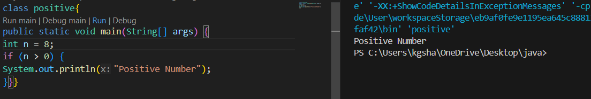

Program 2: Check Whether a Number is Even or Odd
class EvenOdd {
public static void main(String[] args) {
int n = 6;
if (n % 2 == 0)
System.out.println("Even Number");
else
System.out.println("Odd Number");
}}
Output:
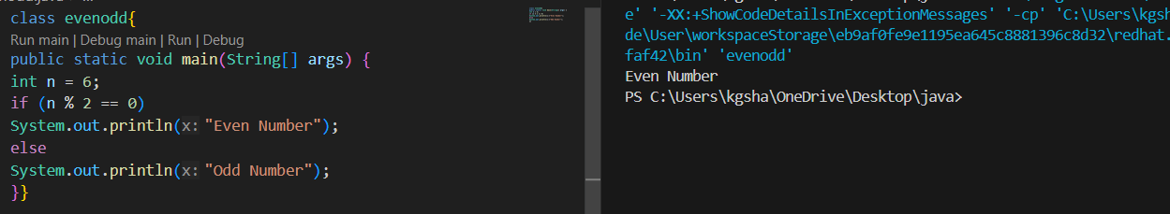
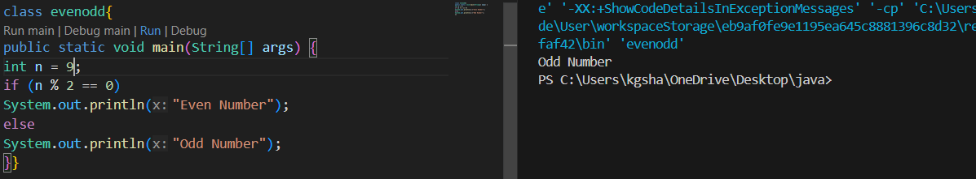Program 3: Find Largest of Two Numbers
class LargestTwo {
public static void main(String[] args) {
int a = 10, b = 20;
if (a > b)
System.out.println("A is largest");
else
System.out.println("B is largest");
}}
Output:
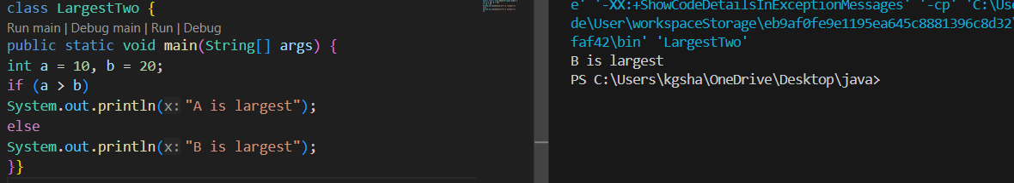
Program 4: Grade Calculation
class Grade {
public static void main(String[] args) {
int marks = 75;
if (marks >= 90)
System.out.println("Grade A");
else if (marks >= 75)
System.out.println("Grade B");
else if (marks >= 50)
System.out.println("Grade C");
else
System.out.println("Fail");
}}
Output:
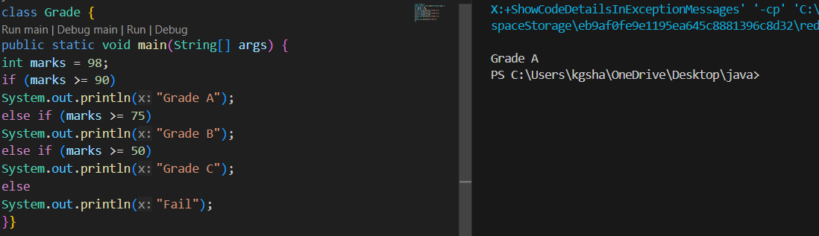
Program 5: Day of the Week
class DaySwitch {
public static void main(String[] args) {
int day = 1;
switch (day) {
case 1: System.out.println("Monday"); break;
case 2: System.out.println("Tuesday"); break;
case 3: System.out.println("Wednesday"); break;
case 4: System.out.println("Thursday"); break;
case 5: System.out.println("Friday"); break;
default: System.out.println("Invalid Day");
}}}
Output:
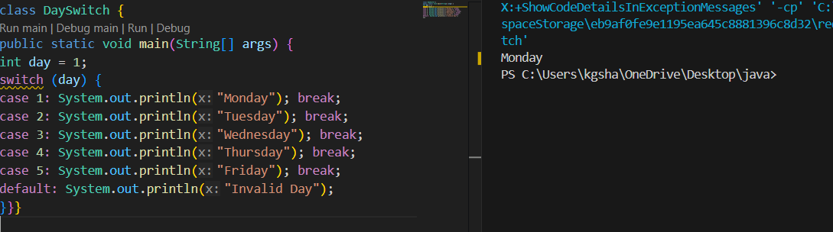Program 6: Print Numbers from 1 to 5
class ForLoop {
public static void main(String[] args) {
for (int i = 1; i <= 5; i++) {
System.out.println(i);
}}}
Output:
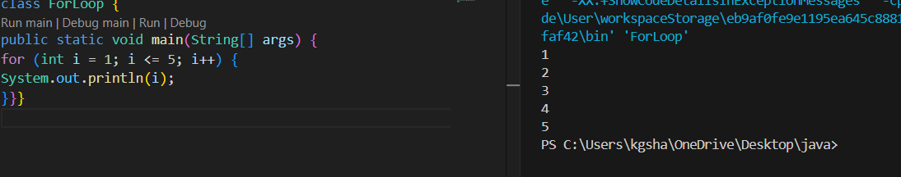
Program 7: Print Numbers from 1 to 5
class WhileLoop {
public static void main(String[] args) {
int i = 1;
while (i <= 5) {
System.out.println(i);
i++;
}}}
Output:
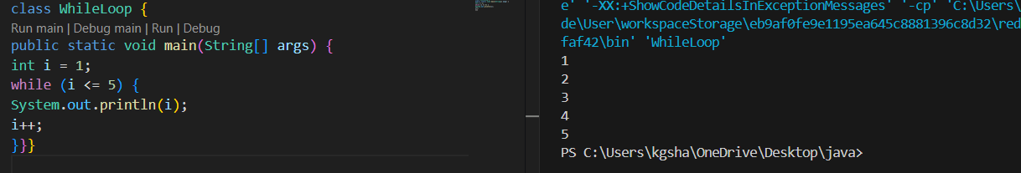
Program 8: Print Numbers from 1 to 5
class DoWhileLoop {
public static void main(String[] args) {
int i = 1;
do {
System.out.println(i);
i++;
} while (i <= 5);
}}
Output:
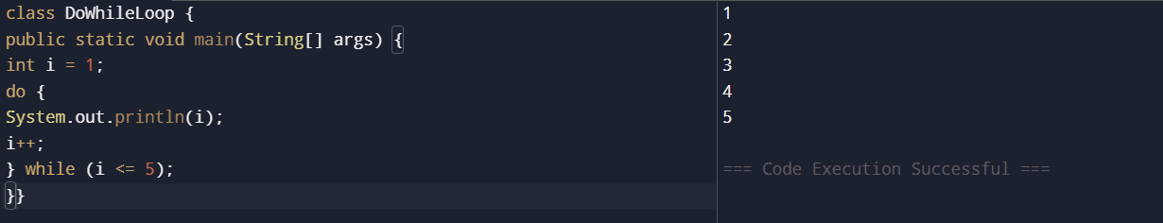
Program 9: Sum of First 5 Natural Numbers
class SumNumbers {
public static void main(String[] args) {
int sum = 0;
for (int i = 1; i <= 5; i++) {
sum = sum + i;
}
System.out.println("Sum = " + sum);
}}
Output:
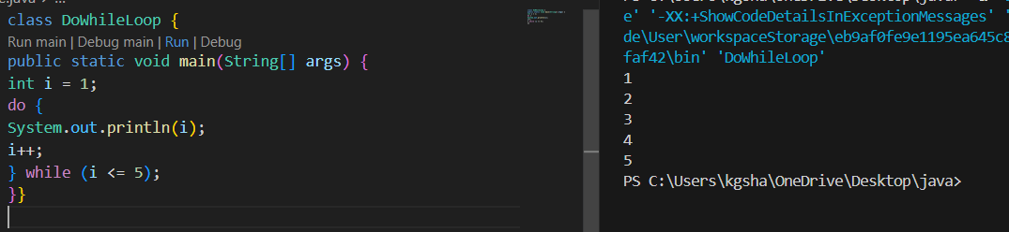Program 10: Multiplication Table of a Number
class MultiplicationTable {
public static void main(String[] args) {
int n = 8;
for (int i = 1; i <= 10; i++) {
System.out.println(n + " x " + i + " = " + (n * i));
}}}
Output:
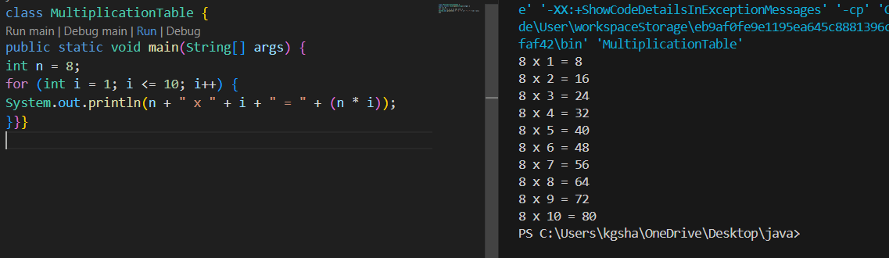
POST LAB EXERCISE
Q1. What is the use of if statement?
Ans:
• The if statement is used to check a condition.
• It executes a block of code only when the condition is true.
Q2. Difference between if-else and else-if ladder.
Ans:
• if-else checks only one condition.
• else-if ladder is used to check multiple conditions one by one.
Q3. Why is switch statement used?
Ans:
• switch statement is used to select one option from many choices.
• It improves readability when comparing a variable with multiple values.
Q4. Difference between for, while, and do-while loops.
Ans:
• for loop is used when the number of iterations is known.
• while loop checks the condition before execution.
• do-while loop checks the condition after execution.
Q5. Which loop executes at least once?
Ans:
• The do-while loop executes at least once.

Result:

Thus the different control statements were executed successfully with expected output.

ASSESSMENT

Description | Max Marks | Marks Awarded
Pre Lab Exercise | 5
In Lab Exercise | 10
Post Lab Exercise | 5
Viva | 10
Total | 30
Faculty Signature

